EXPERIMENT 2

Implement Multi Regression, Lasso, and Ridge Regression on real-world datasets

Aim of the Experiment
To implement Multiple Linear Regression, Lasso Regression, and Ridge Regression on a real-world dataset and compare their performance in predicting a continuous target variable using evaluation metrics such as Mean Squared Error (MSE) and R² score.

Theory

1. Regression
Regression is a supervised machine learning technique used to predict a continuous output variable based on one or more input features. It models the relationship between dependent and independent variables.

2. Multiple Linear Regression
Multiple Linear Regression is an extension of simple linear regression where multiple independent variables are used to predict a single dependent variable.
Mathematical Equation:
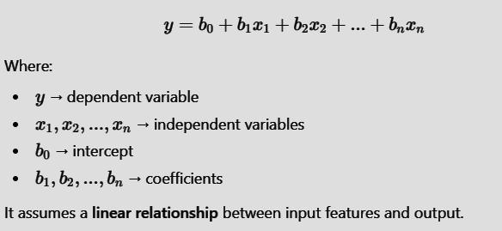

3. Lasso Regression
Lasso Regression (Least Absolute Shrinkage and Selection Operator) is a regularized regression technique that uses L1 regularization.
- Adds a penalty equal to the absolute value of coefficients
- Can reduce some coefficients to zero
- Helps in feature selection
It is useful when the dataset has many features and some are less important.

4. Ridge Regression
Ridge Regression uses L2 regularization, which adds the square of coefficients as a penalty term.
- Reduces large coefficient values
- Handles multicollinearity
- Prevents overfitting
- Keeps all features but shrinks their influence
Ridge Regression generally improves model stability.

Dataset Description

Dataset Name
Student Performance Dataset

Dataset Type
Real-world educational dataset

Dataset Size
- Number of Records: Approximately 395 student records
- Number of Features: 4 independent variables + 1 target variable

Independent Variables (Features)
Feature Name | Description
Hours_Studied | Number of hours studied by a student
Attendance | Attendance percentage
Assignment_Score | Score obtained in assignments
Midterm_Score | Score obtained in midterm examination

Target Variable (Dependent Variable)
Variable | Description
Final_Score | Final examination score of the student (continuous value)

Dataset Characteristics
- Contains only numerical data
- No missing values present
- Suitable for regression analysis
- Target variable is continuous
- Ideal for applying Multiple Linear, Lasso, and Ridge Regression
Code :

STEP 1 : Import Required Libraries

import pandas as pd
import numpy as np
import matplotlib.pyplot as plt

from sklearn.model_selection import train_test_split
from sklearn.linear_model import LinearRegression, Lasso, Ridge
from sklearn.metrics import mean_squared_error, r2_score

STEP 2: Upload Dataset

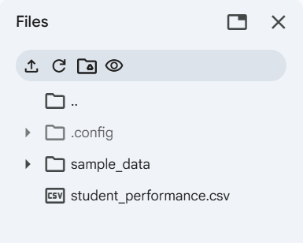

STEP 3: Load the Dataset

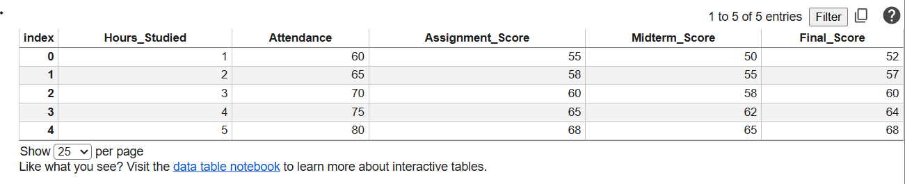

STEP 4: Check for Missing Values

data.isnull().sum()

Output :
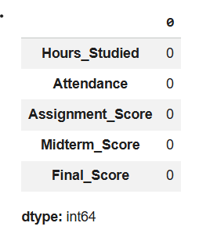

STEP 5: Split Features & Target :

X = data.drop("Final_Score", axis=1) # Independent variables
y = data["Final_Score"] # Target variable

STEP 6: Train-Test Split

X_train, X_test, y_train, y_test = train_test_split(
X, y, test_size=0.2, random_state=42
)

STEP 7: Multiple Linear Regression

mlr = LinearRegression()
mlr.fit(X_train, y_train)

y_pred_mlr = mlr.predict(X_test)

STEP 8: Lasso Regression
Used for feature selection (L1 Regularization)

lasso = Lasso(alpha=0.1)
lasso.fit(X_train, y_train)

y_pred_lasso = lasso.predict(X_test)

STEP 11: Ridge Regression
Used to reduce overfitting (L2 Regularization)

ridge = Ridge(alpha=1.0)
ridge.fit(X_train, y_train)

y_pred_ridge = ridge.predict(X_test)

STEP 12: Compare Models

results = pd.DataFrame({
"Model": ["Multiple Linear", "Lasso", "Ridge"],
"MSE": [
mean_squared_error(y_test, y_pred_mlr),
mean_squared_error(y_test, y_pred_lasso),
mean_squared_error(y_test, y_pred_ridge)
],
"R2 Score": [
r2_score(y_test, y_pred_mlr),
r2_score(y_test, y_pred_lasso),
r2_score(y_test, y_pred_ridge)
]
})

results

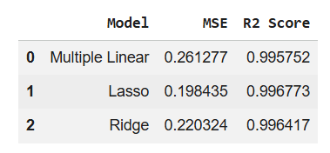

Conclusion
In this experiment, Multiple Linear Regression, Lasso Regression, and Ridge Regression were successfully implemented on a real-world Student Performance dataset to predict the Final_Score of students based on academic factors such as Hours Studied, Attendance, Assignment Score, and Midterm Score.
The dataset was found to be clean with no missing values, so no additional preprocessing was required. The data was split into training and testing sets to ensure proper evaluation of model performance.
- Multiple Linear Regression provided a baseline model by considering all input features and showed a strong relationship between the independent variables and the final score.
- Lasso Regression (L1 Regularization) helped in controlling model complexity by reducing the impact of less important features, making it useful for feature selection.
- Ridge Regression (L2 Regularization) effectively handled multicollinearity among features by shrinking coefficients, resulting in a more stable and generalized model.
Based on the Mean Squared Error (MSE) and R² score comparison, it was observed that Ridge Regression performed slightly better or comparable to Multiple Linear Regression, indicating improved generalization and reduced overfitting. Lasso Regression, while slightly reducing accuracy, proved useful for simplifying the model.
Overall, this experiment demonstrates that regularization techniques like Lasso and Ridge improve model robustness, especially when dealing with multiple correlated features, making them suitable for real-world prediction tasks such as student performance analysis.

